**Aim: Recovering and Inspecting the recovered files.**

**I) Check for deleted files.**

**II) Recover the Deleted Files.**

Steps:

1) First, create a text file and paste some data in it and store it in a folder.

2) Open AccessData FTK Imager then click on file and select “Create Disk image”.

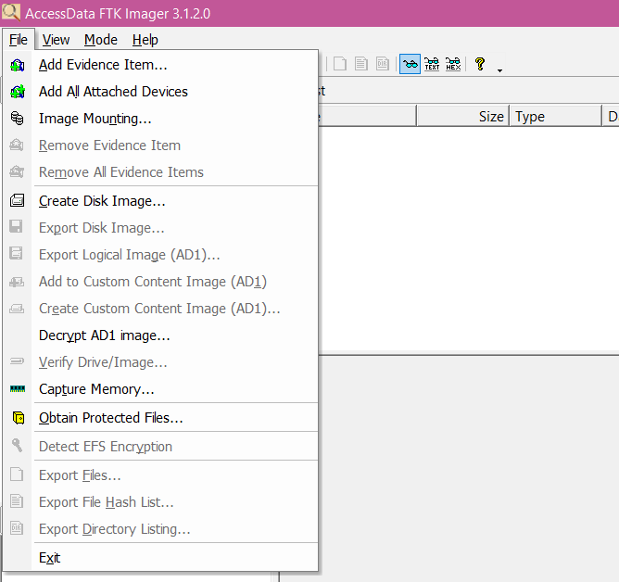

3) Select source as Content of a folder and click on next.

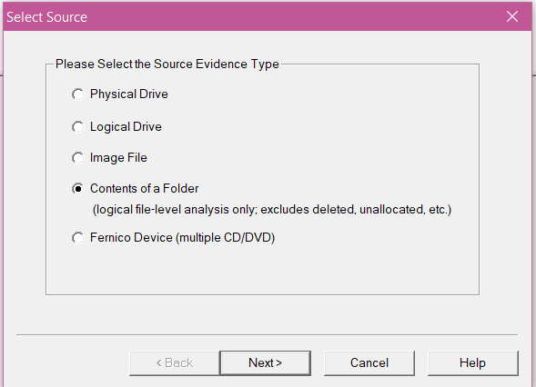

4) Then browse the source evidence that we created previously as a text file then click on finish.

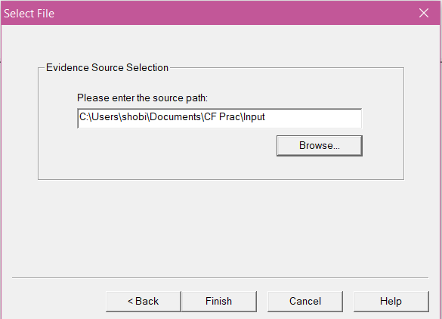

5) Enter the evidence item information and click on next.

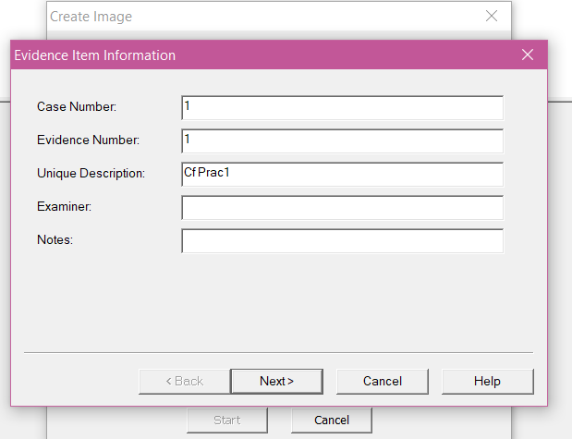

6) Then browse the image destination folder and name the image file and click on finish.

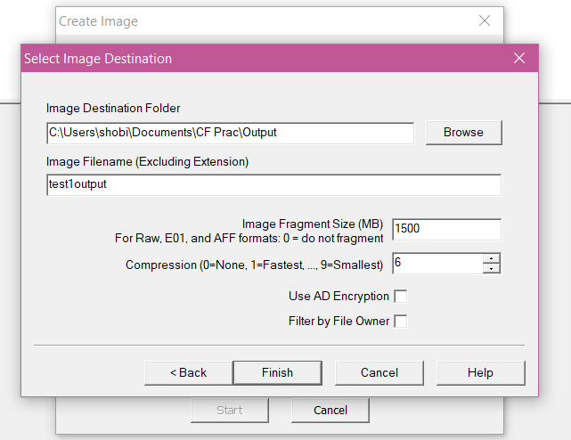

7) For creating and image, click on start.

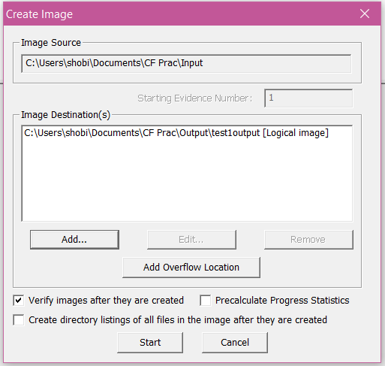

8) As we get the result, we can verify by looking at the verify result of both the hashing functions.

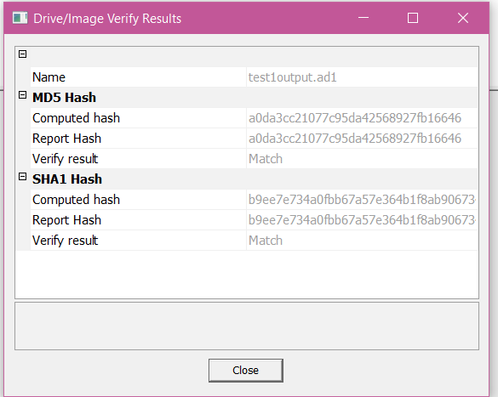

9) Atlast, we get the status of the creation and we can also view image summary.

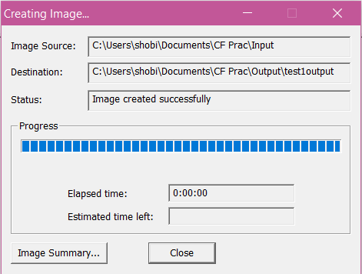

10) For adding an evidence, select “Add evidence item”.

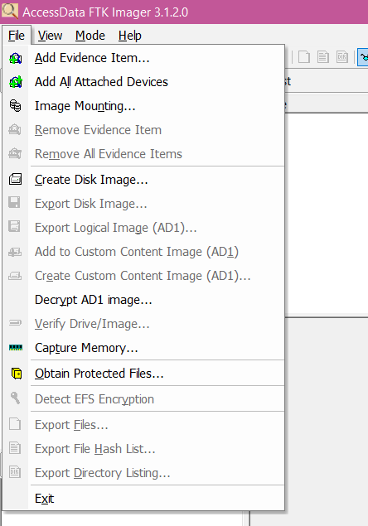

11) Select source as image file and click on next.

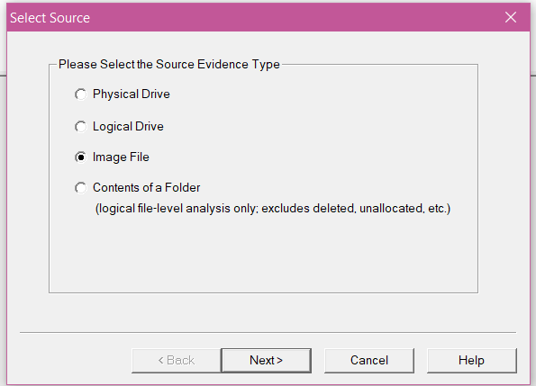

12) Then browse the path of the evidence source and click on finish.

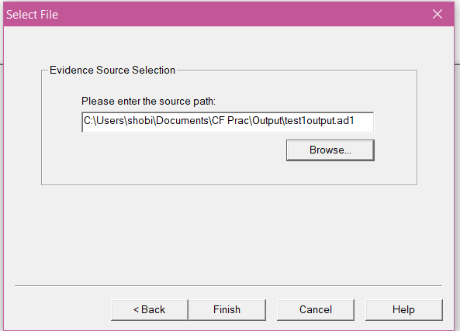

13) In the evidence tree we can see the image file that we created.

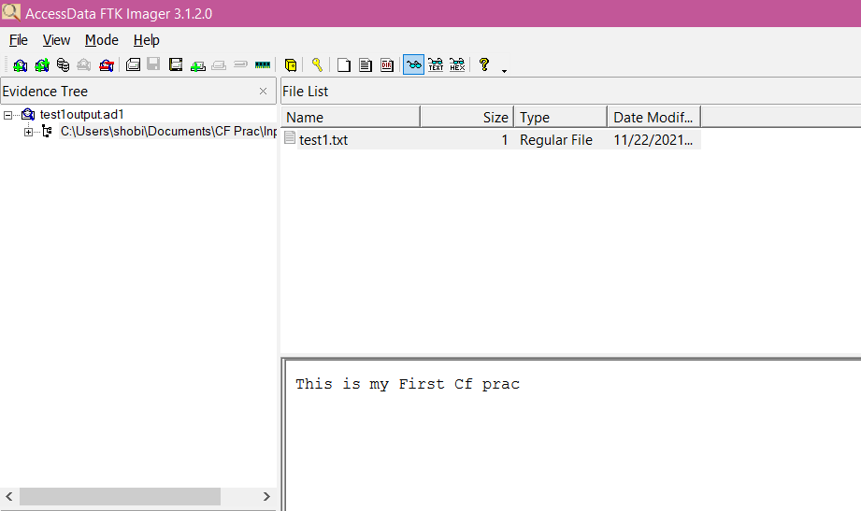

**III) Analyzing and inspecting the recovered files.**

**Perform this using recovery option in ENCASE and also Perform manually through command line.**

Steps:

1) Download TestDisk zip file.

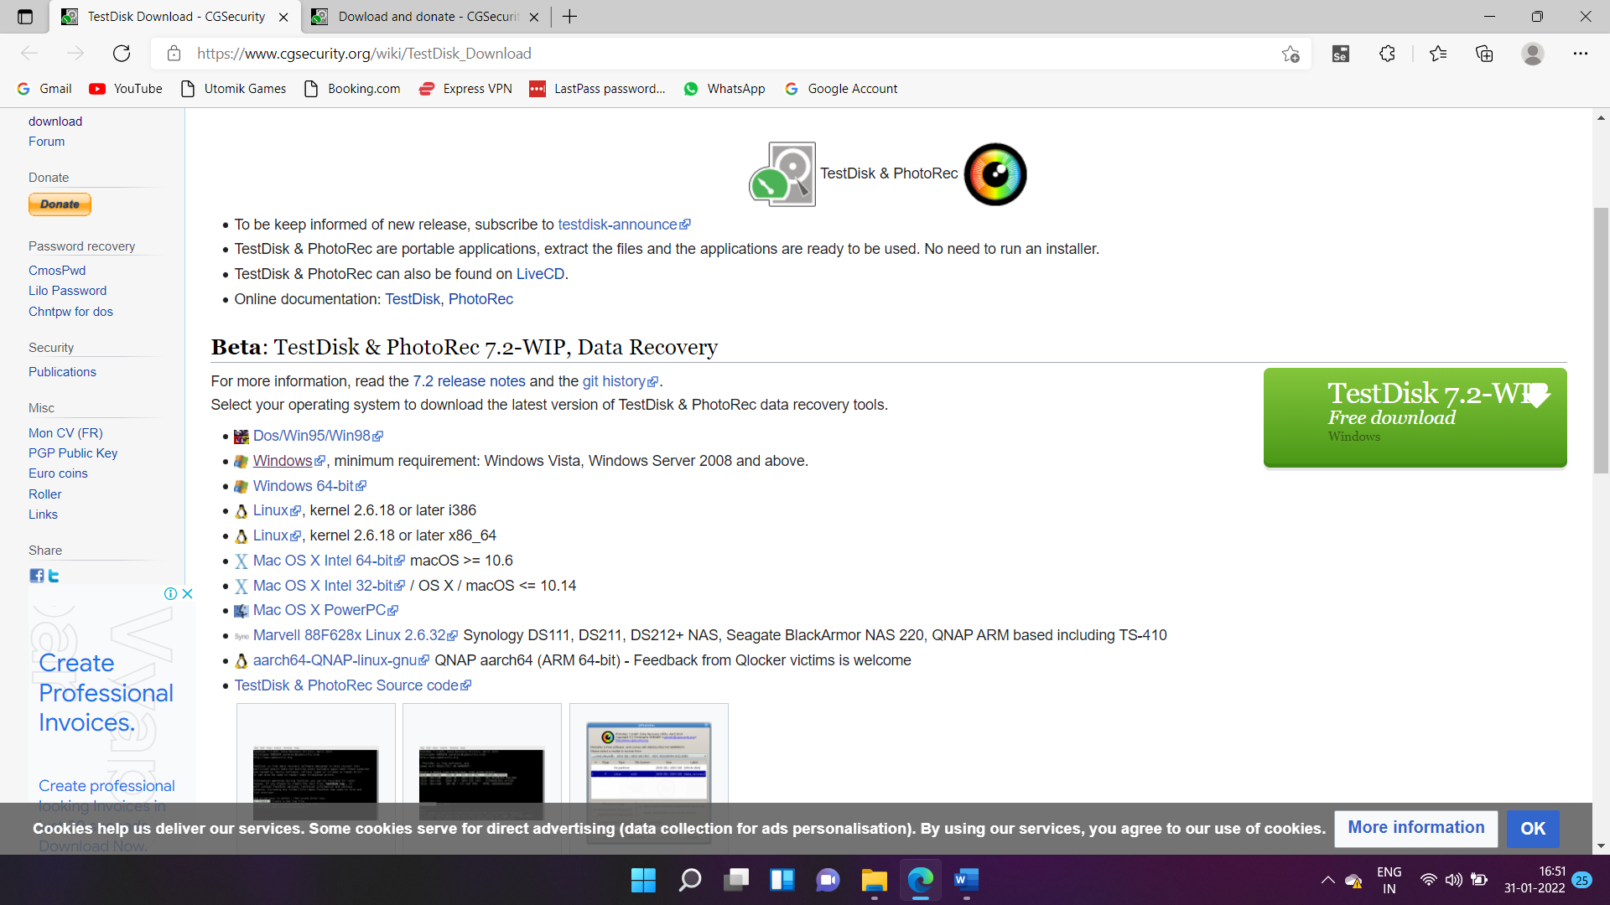

2) Extract the downloaded file in a folder.

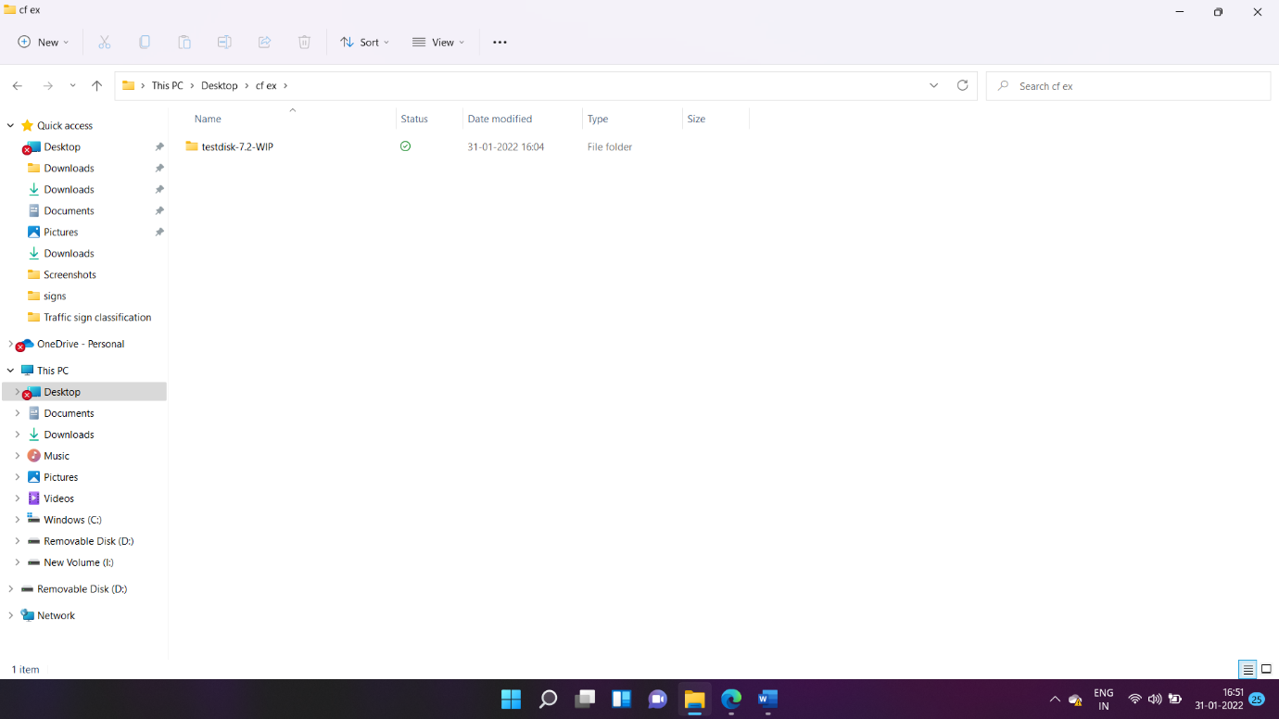

3) In that file, open “photorec_win” application.

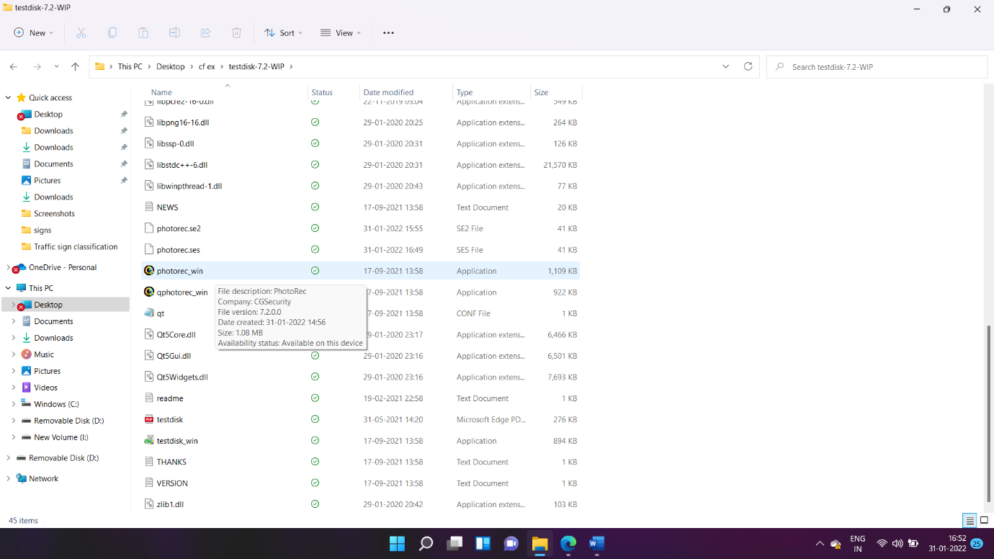

4) Then select the pen drive that you attached to your PC and proceed.

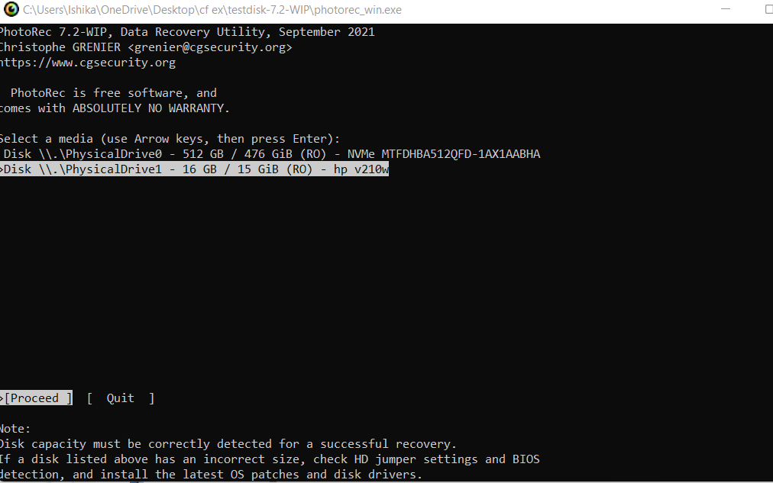

5) Then select the drive with the name of your pen drive and proceed.

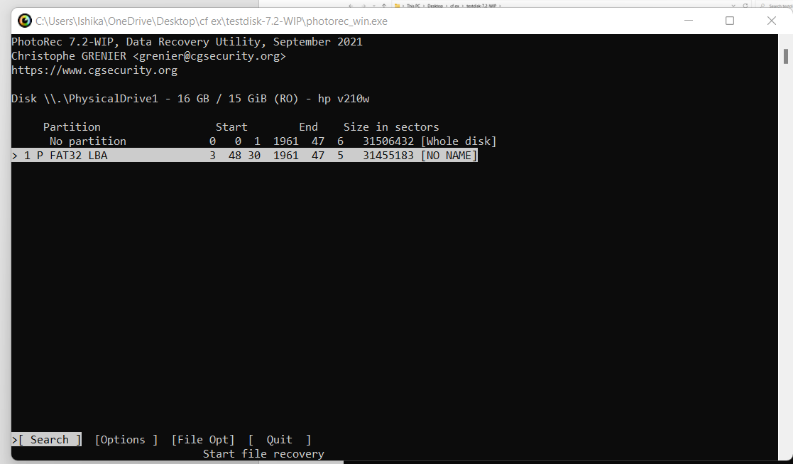

6) Then select on Other and proceed.

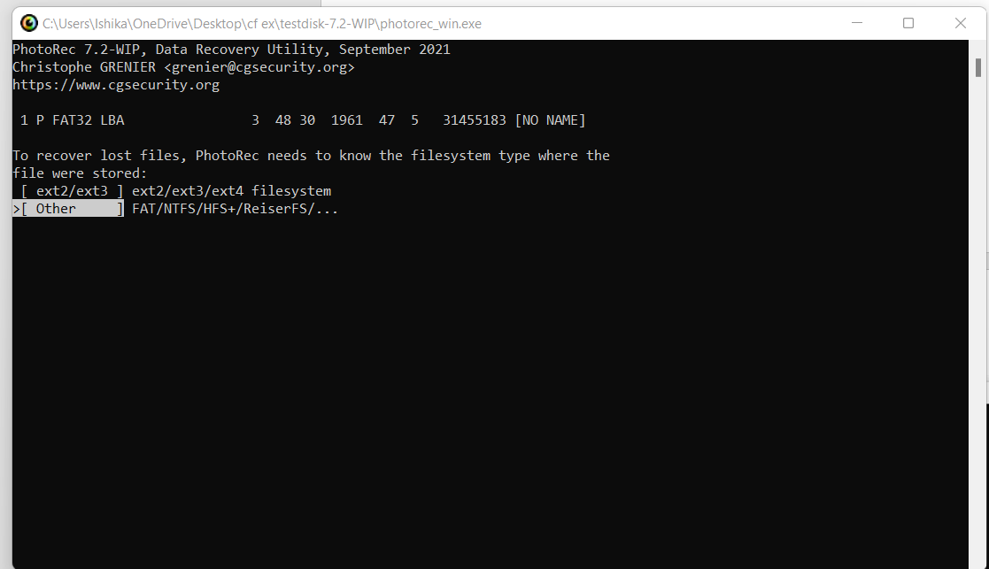

7) Select “Whole” for extracting files from whole partition and proceed.

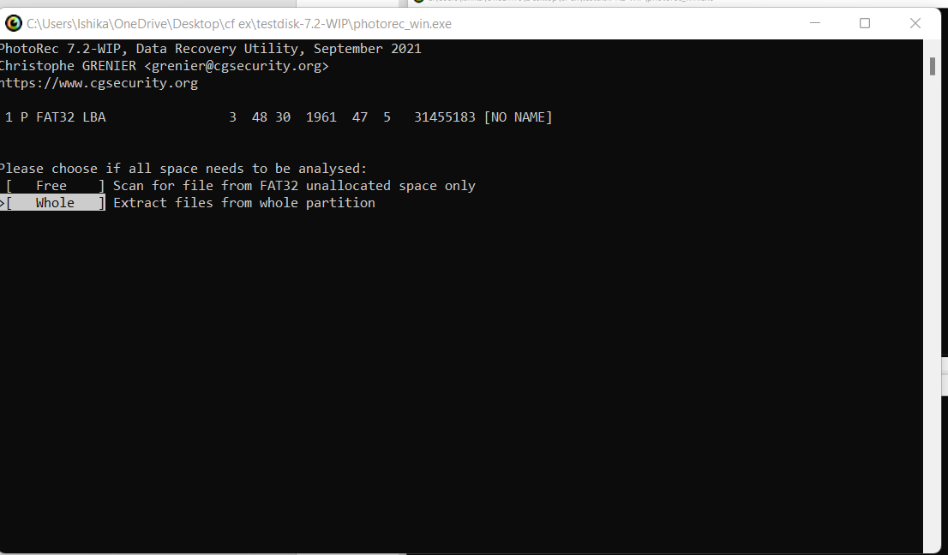

8) Then for going to another directory or drive use left arrow key on your keyboard, then select the pen drive to store the deleted data.

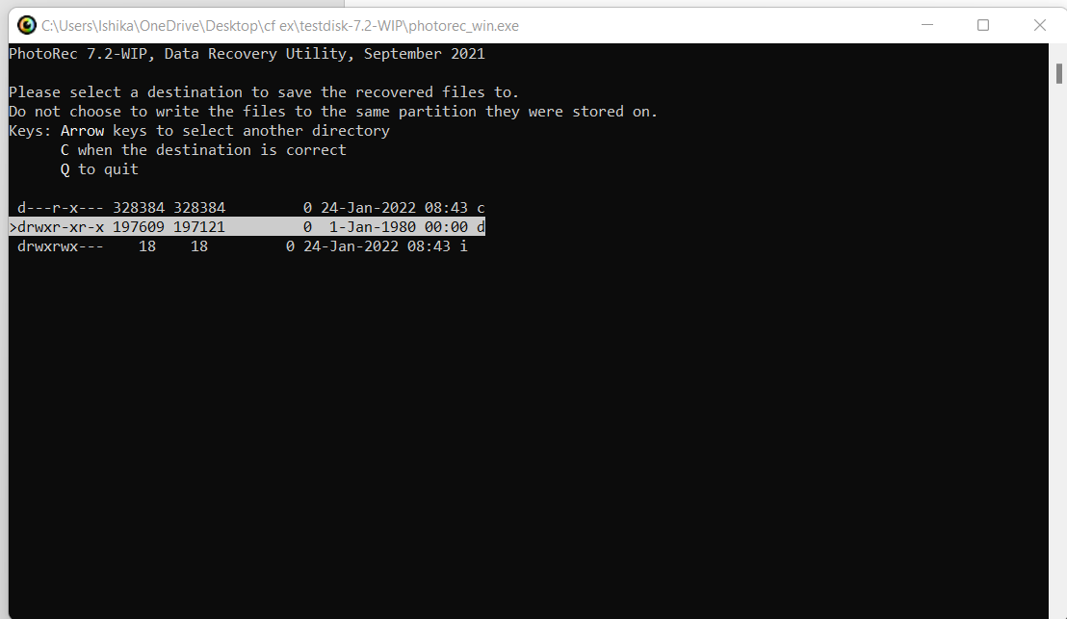

9) After reaching the destination, press C key on the keyboard. After that the process will start.

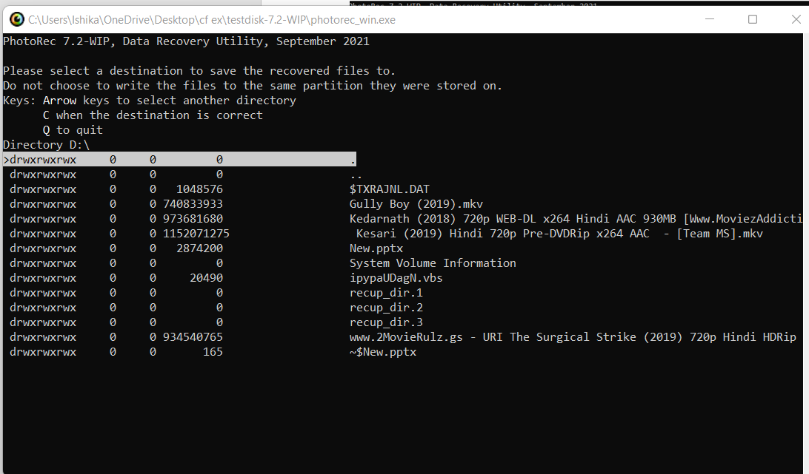

10) Atlast, we can see that the files that were deleted are successfully retrieved.

